STINGER Soft Drive Installation
Make sure power supply to motor is off. ( Recommend batteries be disconnected and spark plugs pulled before installation for safety purposes.)
Install Soft Drive bushings with the large steel head flush against the flywheel. Install soft drive bolts with bolt heads entering from the motor side only. The washers and lock nuts are threaded on from the other side; (when installed properly the washers and lock nuts will be facing outward where they are visible from stern of boat). Torque to 45 - 50lbs. There are three large green bushings and three small orange bushings. Install bushings one at a time pulling motor through.

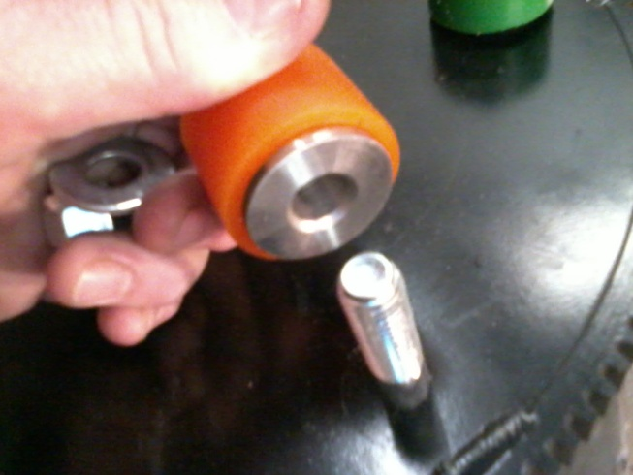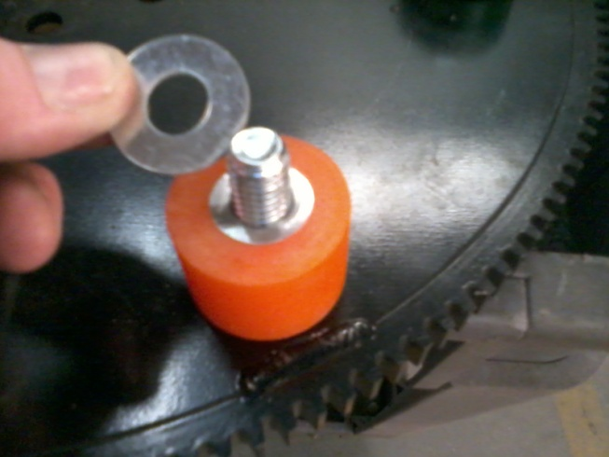

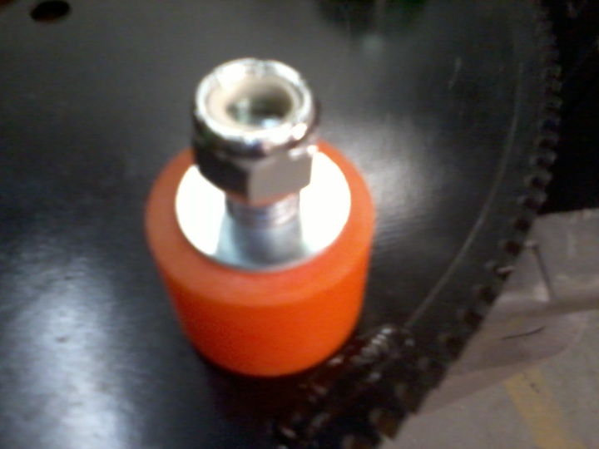
For optimal performance and wear protection Stinger Drives Inc. recommends servicing the gearbox every 40 hours or every year, whichever comes first. 1 quart Amsoil Synthetic Severe Gear 75w-140 is the recommended oil, but any name brand Full Synthetic is acceptable.

